RULES OF THE GAME

There’s a lot to discover on the ice floes of Greenland …

Enuk, the little Eskimo boy, is really excited. He’s been looking forward to wandering around with his brothers for a long time. Up to now they have only told him stories about all the polar bears and seals they encounter, but now he is to get to see the animals for himself. He’s also to be allowed to help build a new igloo, and that’s what he’s looking forward to most.

The players have to try to collect as many animal tiles as possible. The one who has the most tiles is the winner!

Game Materials

1 game board with

- 9 sun fields for the sun piece, which is placed on the left-hand field at the start of the game.

- 9 igloo fields for the joint construction of the igloo

This is the sequence in which the animals flee

56 animal tiles – 14 polar bears, 14 seals, 14 salmon and 14 herring



20 Eskimo figures – 4 in each of the five player colours



9 reindeer tiles

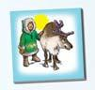

9 igloo tiles

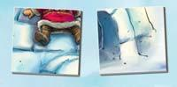

1 sun piece



Preparing the Game

The game board is placed in the middle of the table where everyone can see it.

All of the tiles are mixed together and spread out

face down next to the board.

The sun piece is placed on the left-hand sun field of the board.

Each player now takes 4 Eskimo figures in the colour of his or her choice and the game can start.

Note: The game is easier if the tiles are laid out in neat rows.

Game Sequence

The game runs in two phases:

Phase 1: Collecting tiles and building the igloo

Phase 2: Finishing phase

The youngest player starts the game with Phase 1.

**Collecting tiles and building the igloo**

Turn over any tile you like when it’s your turn. All of the other players must be able to see the picture on the tile.

You can keep turning over tiles until you:

No longer want to turn over any more or

Turn over an igloo tile and play an Eskimo figure Or Allow animals to flee

When your turn is over, pick up all of the tiles that are still lying open and lay them out in front of you in a pile.

It is now the turn of the player on your left.

**Choose not to turn over any more tiles**

You can pick up the tiles that have been turned face up and stack them open in front of you.

You can end your move whenever you like, even if several tiles have already been turned over.

**Turn over an igloo tile and play an Eskimo figure**

If you turn over an igloo tile, you should place it on the corresponding igloo square on the board.

Mark the tile you have just laid by placing one of your Eskimo figures on it.

If you don’t have any more figures, you can’t mark the igloo tile. When this happens, lay the tile on the board without an Eskimo.

You can now pick up all of the animal tiles still lying face up and place them in front of you.

Your move is over.

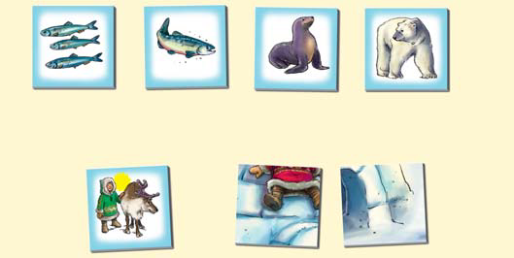

If you turn over an igloo tile, you must lay it face up on the board and mark it with one of your Eskimo figures. You have then helped to build the igloo.

Note: Eskimo figures on igloo tiles are important during the Finishing phase.

allowing animals to flee

The herring flee from the salmon, the salmon flees from the seal. the seal flees from the polar bear, the polar bear flees as soon as a reindeer turns up with an Eskimo.

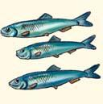 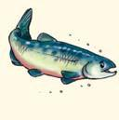 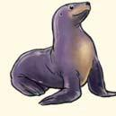 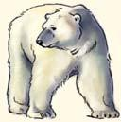 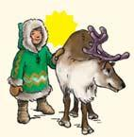

If you allow animals to flee, your move ends immediately. The fleeing animals are turned back in the other direction and you can pick up the tiles that are still lying open.

Note: To help your memory, the sequence in which the animals flee is shown on the board.

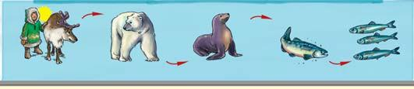

Example:

Tommy turns over a polar bear and decides to turn over another tile. This time it’s the herring, so if Tommy ends his move now he can pick up both of these tiles.

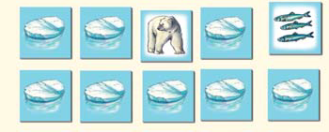

He decides to turn over another tile, however. More herring.

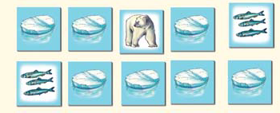

The next tile he turns over is a salmon. His move ends because the herring flee from the salmon.

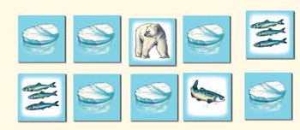

Tommy has to turn over the two herring tiles. He can only pick up the polar bear and the salmon.

 ✘

Note: It can happen that different animals flee during one move.

Example: Anne has turned over 1 polar bear and 2 salmon. The next tile she turns over is a seal. The 2 salmon flee from the seal and the seal flees from the polar bear. Anne has to turn the 2 salmon tiles and the seal tile back over. She can only pick up the polar bear tile.



Special Case: A reindeer is turned over

If you turn over a reindeer, you must look after it, and this takes time.

This means that you have to move the sun piece one field to the right.

You can pick up every reindeer that is lying face up.

Reindeer cannot be chased away, so your move is not finished.

When you turn over a reindeer, you must move the sun piece one field to the right. If you turn over 2 reindeer in one move, you have to move the sun piece 2 fields to the right.

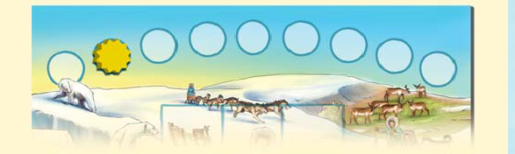

Phase 2 begins when the sun piece is moved onto the last field on the board.

If you move the sun piece onto the last field, your turn ends and the game moves on to the ...

**Finishing Phase**

It is the turn of the next player on the left.

If you have an Eskimo figure on the board, you can now remove your marked igloo tile and Eskimo figure.

Place the figure back in front of you and lay the igloo tile on the stack of animal and reindeer tiles you have already collected.

It’s important for you to remember now where all of the different animals are hidden. Pick a type of animal and say out loud which animal you intend to look for.

You can now turn over any tile and keep it if the right animal is on it. You then name another animal and turn over another tile.

If you turned over the wrong animal, the tile remains lying face up and it is the turn of the next player.

If this player also has an Eskimo on the board, he or she must say out loud which animal they are looking for and turn over a concealed tile.

If he/she does not have an Eskimo on the board, no tile may be turned over and it is the turn of the next player.

The sequence of play is not interrupted, even if one player has several Eskimos on the igloo.

This player can then look for several animals when his or her turn comes round again.

Note: An animal tile that has been left lying face up cannot be collected!

Example:

Anne wants to turn over a polar bear, so she says “polar bear” out loud and turns over a tile.

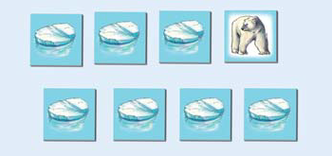

It really is a polar bear, so she gets to keep the tile. Now she wants to turn over a seal.

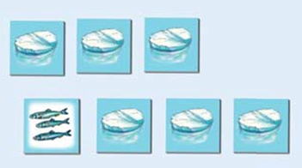

Unfortunately, she turns over a herring tile and her turn is over.

The tile remains lying face up

End of the Game

The game ends when there are no more Eskimos on the board or all animal tiles have been turned over.

Did you manage to collect the most tiles? If you did, you’ve won the game.





A game by Stefan Dorra (www.dorra-spiele.de) and Manfred Reindl for 2-5 players aged 5 and over.

© Copyright 2008 Queen Games, D-53842 Troisdorf, Germany